5 parts ABCDE puzzle – 1,1,1,1,1

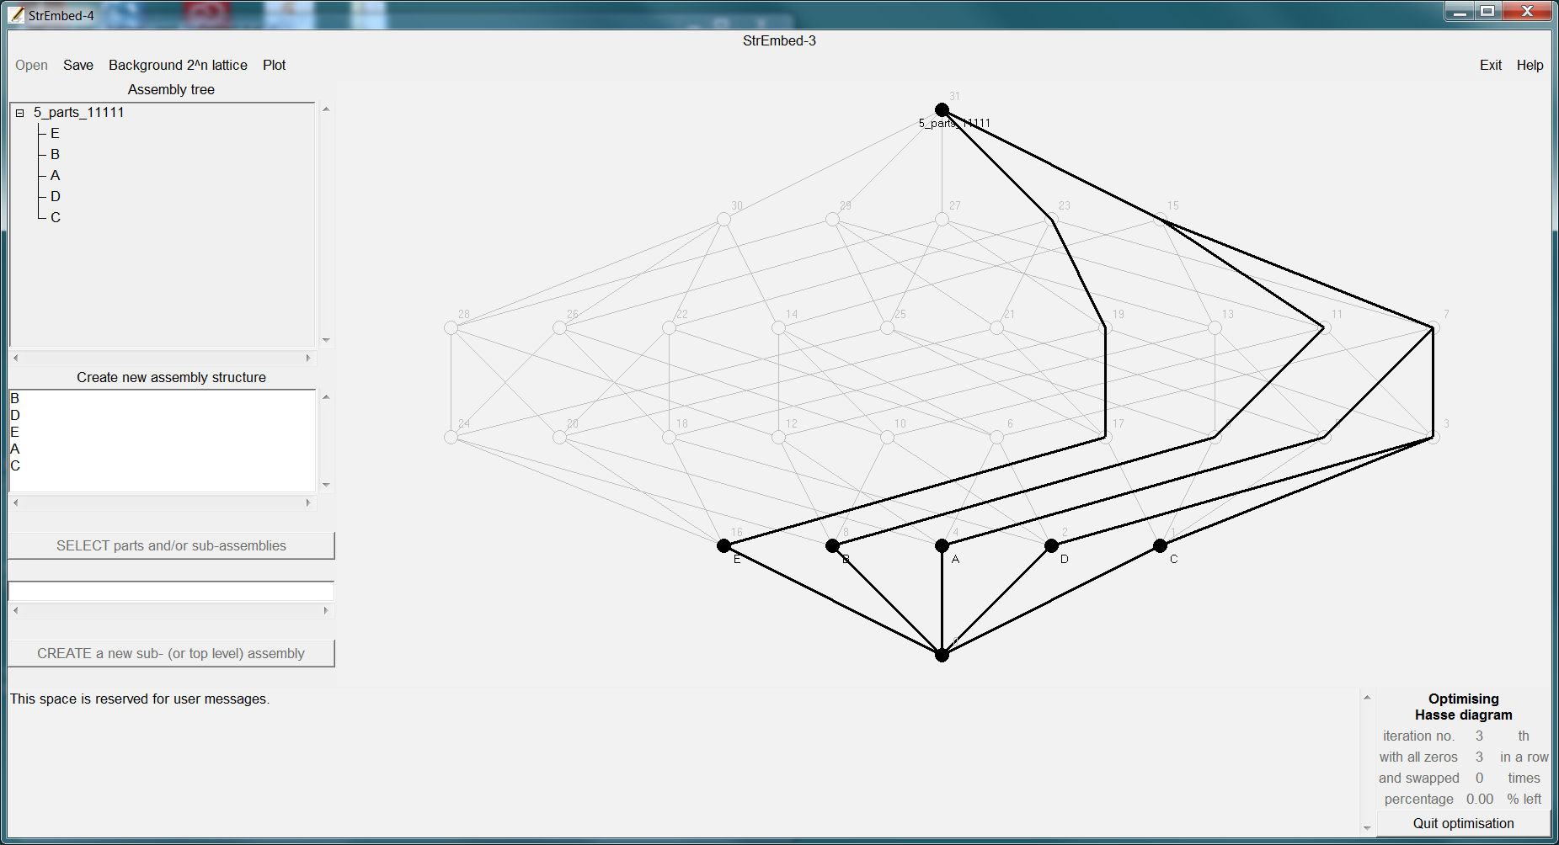

5 parts ABCDE puzzle – 4,1

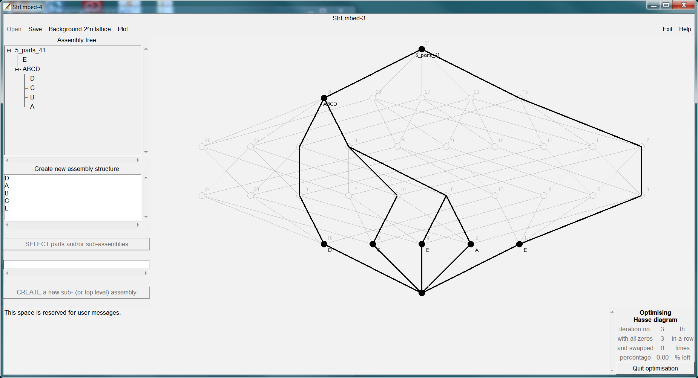

5 parts ABCDE puzzle – 3,1,1

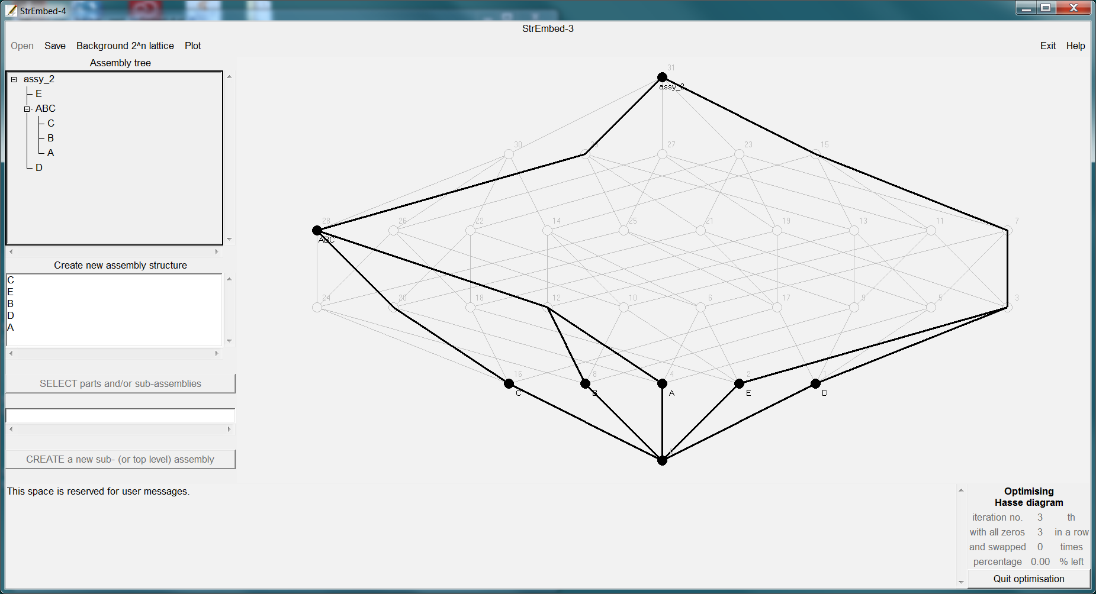

5 parts ABCDE puzzle – 3,2

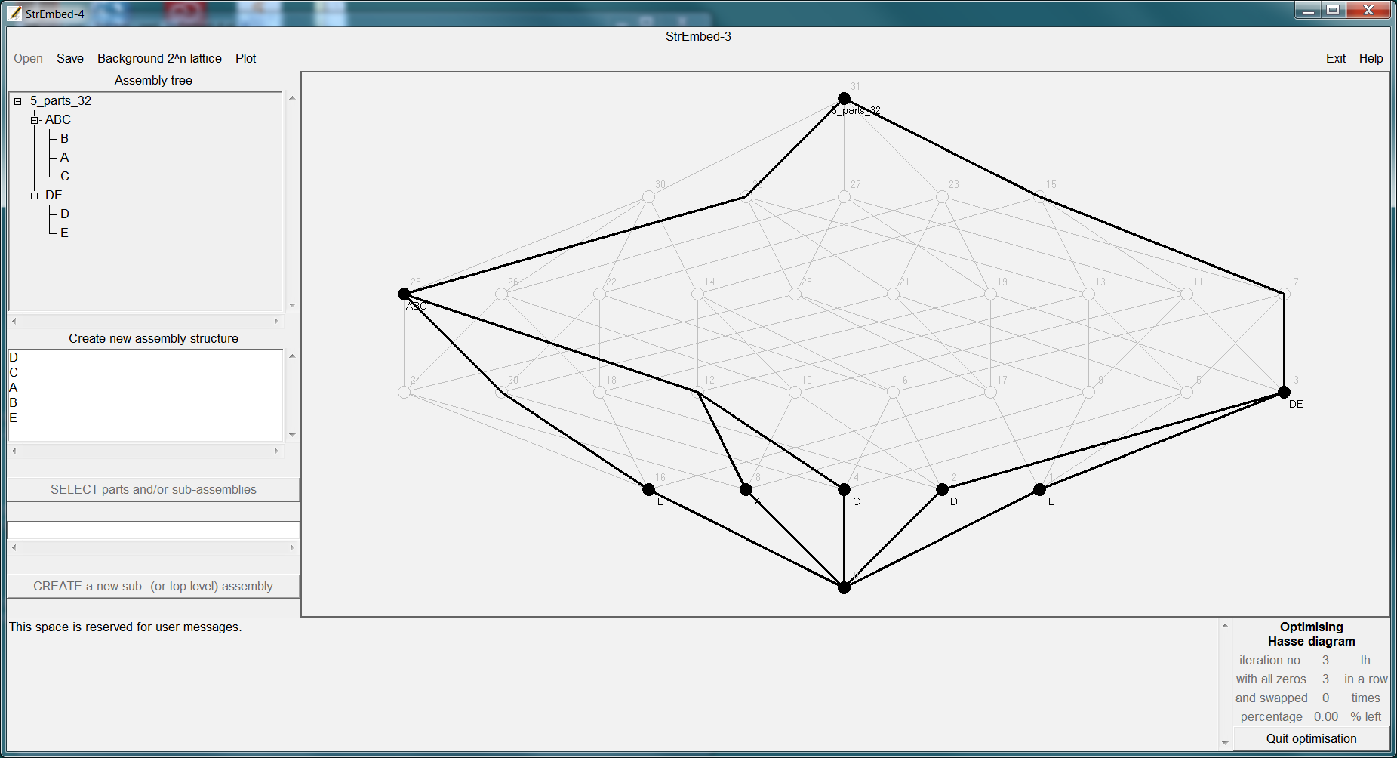

5 parts ABCDE puzzle – 2,2,1

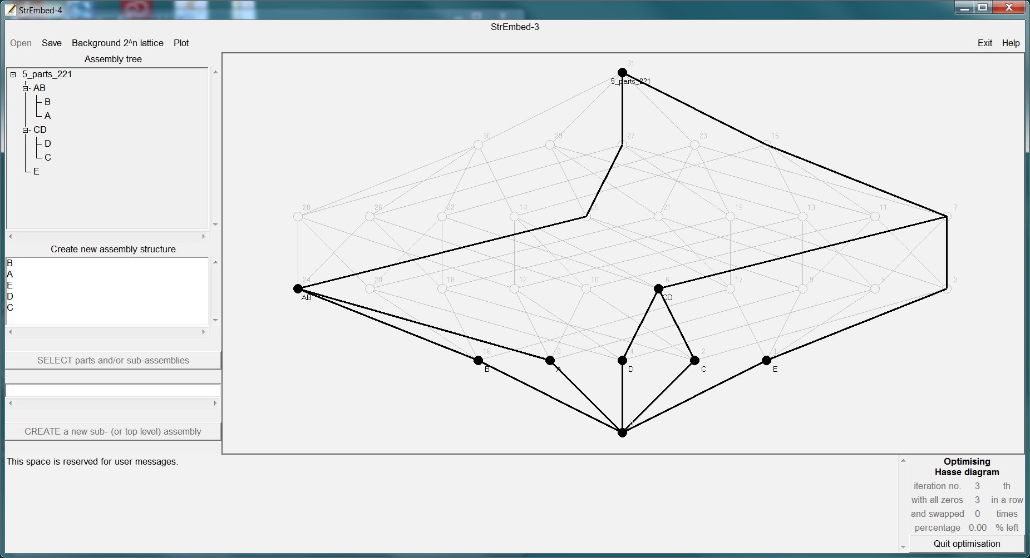

5 parts ABCDE puzzle – {3,1},1

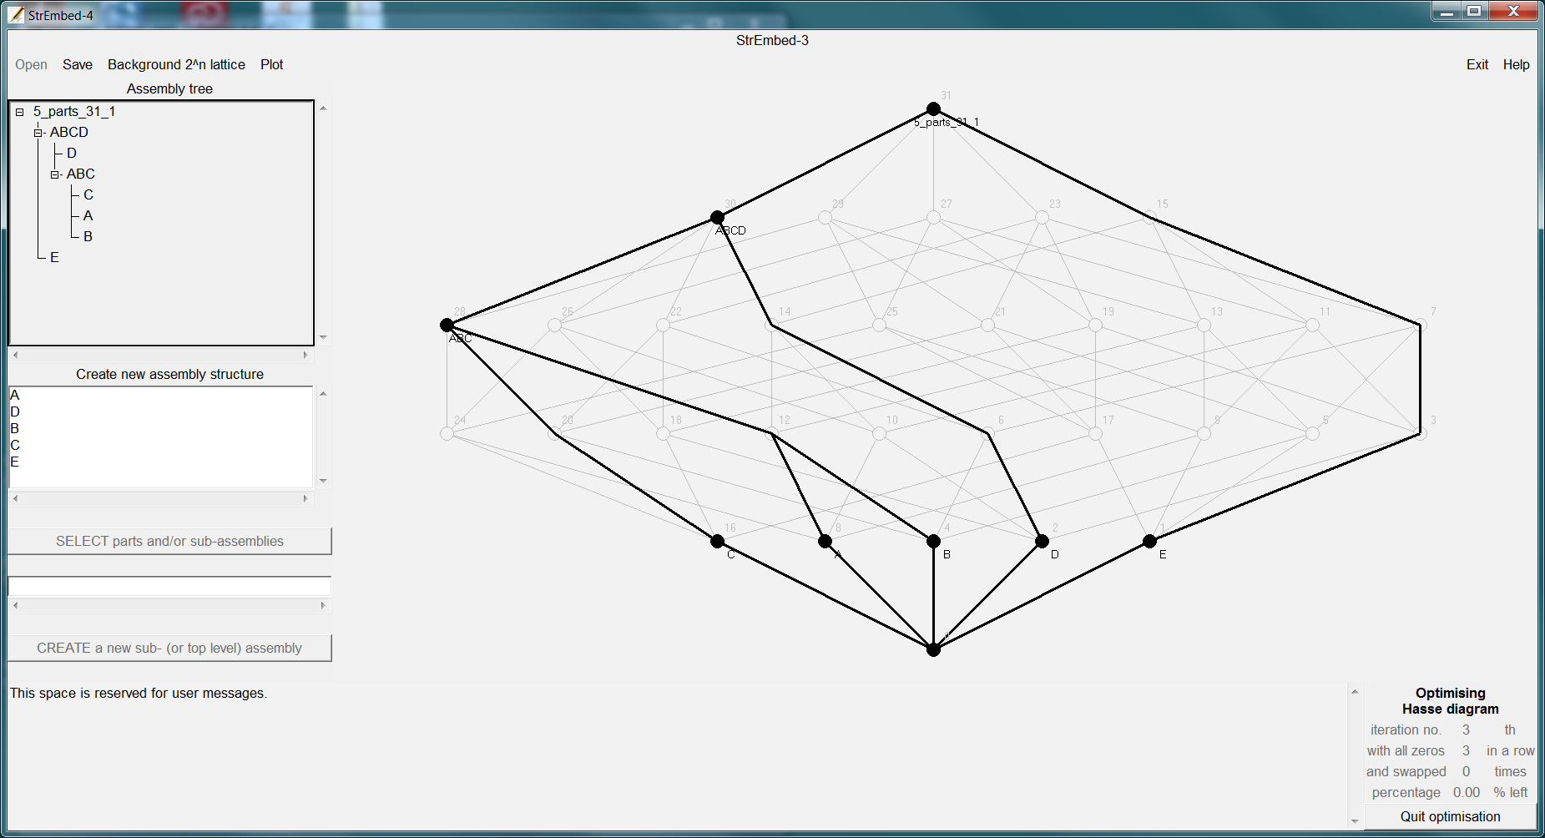

5 parts ABCDE puzzle – {{3,1},1},1

